Risk Wins, Risk Loses
One of the most favorite Bulgarian TV presenters is Kutsi Vuptsarov (he is also well known with his song “Hey, grandma”). He loves all possible games which involve any kind of wheels. One day he thought that his once famous game “Risk Wins, Risk Loses” must be reborn with some new wheel games. Since you are a big fan of his jokes (and his song) you should help him by writing a program which finds the best solution of his new 5-wheel based game.

Digits in the range from 0 to 9 are painted consecutively clockwise on the periphery of each wheel. The topmost digits of the wheels form a five-digit integer. For example, in the following figure the wheels form the integer 88056.
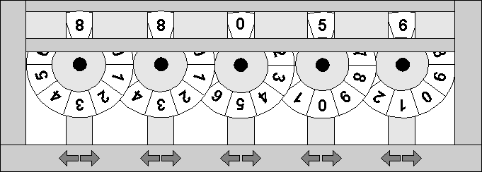
Each one of the five wheels has two buttons associated with it. When you press the button marked with a left arrow you rotate the wheel one digit clockwise and when you press the one marked with the right arrow you rotate it one digit in the opposite direction.
The game starts with an initial configuration of the wheels, given by the topmost digits of the wheels. You will be given N forbidden configurations and a target configuration, also given by the topmost digits.
Your task is to write a program that calculates the minimum number of button presses required to transform the initial configuration to the target configuration by never passing through a forbidden one.

Input
The input data should be read from the console.
The first input line contains the initial configurations of the wheels.
The second line contains the target configuration of the wheels.
On the third line there will be the number N. Each of the following N lines contains a forbidden configuration.
The input data will always be valid and in the described format. There is no need to check it explicitly.

Output
The output data should be printed on the console.
On the only output line print the minimum number of button presses required.
If the target configuration is not reachable then print -1.

Constraints
- The number of the wheels will always be exactly 5.
- N will be between 0 and 150 000, inclusive.
- All configurations will be given by the topmost digits of the wheels.
- Allowed working time for your program: 0.15 seconds. Allowed memory: 16 MB.

Examples
Input example | Output example
88056  86508  5  88057  88047  85508  87508  86408 | 14
You need at least 14 button presses in order to change 88056 to 86508 without passing through forbidden combination.
Input example | Output example
00000  65536  10  00001  00010  00100  01000  10000  90000  09000  00900  00090  00009 | -1
You could never change the initial combination because of the forbidden combinations.

